Null Hypotheses:

- H_{o} – for PS is that the number of LEFT and RIGHT turns are same
- H_{o} – for PA is that the number of LEFT and RIGHT turns are same
- H_{o} – for PR is that the number of LEFT and RIGHT turns are same

Alternative Hypotheses:

- H_{a} – for PS is that the number of LEFT and RIGHT turns are not same
- H_{a} – for PA is that the number of LEFT and RIGHT turns are not same
- H_{a} – for PR is that the number of LEFT and RIGHT turns are not same

Write-up:

- For the PS questions, the sign test result indicates a significant result (N = 24, p = .019, p <.05) that rejects the null hypothesis that for PS the number of LEFT and RIGHT turns are same. This indicates that for PS questions, more liars turn their eyes to right than left significantly.
- For the PA questions, the sign test result indicates a significant result (N = 24, p = .039, p <.05) that rejects the null hypothesis that for PA the number of LEFT and RIGHT turns are same. This indicates that for PA questions, more liars turn their eyes to right than left significantly.
- For the PR questions, the sign test result indicates a non-significant result (N = 24, p = .815, p>.05) that fails to reject the null hypothesis that for PA the number of LEFT and RIGHT turns are same. This indicates that for PR questions, there is no significant difference for the liars to turn their eyes to the left or to the right.

Data file:

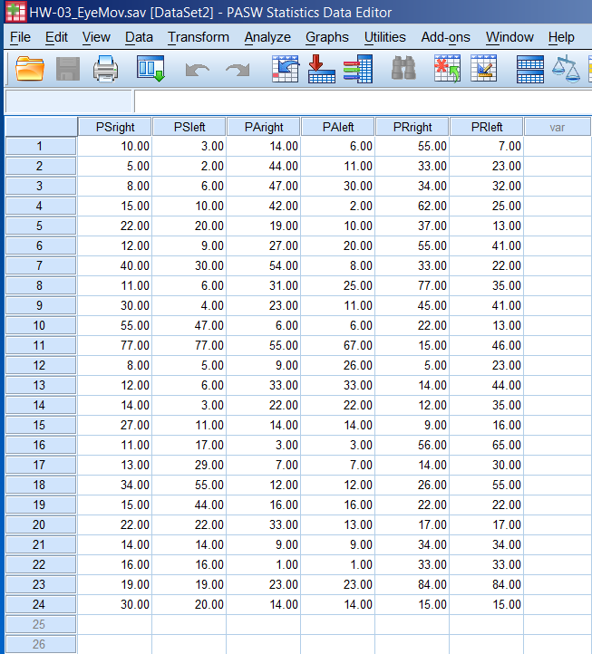

SPSS Output:

NPar Tests

Descriptive Statistics
 | N | Mean | Std. Deviation | Minimum | Maximum
PSright | 24 | 21.6667 | 16.61761 | 5.00 | 77.00
PAright | 24 | 23.2500 | 16.00611 | 1.00 | 55.00
PRright | 24 | 33.7083 | 21.61215 | 5.00 | 84.00
PSleft | 24 | 19.7917 | 18.99423 | 2.00 | 77.00
PAleft | 24 | 16.2083 | 13.94080 | 1.00 | 67.00
PRleft | 24 | 32.1250 | 17.91116 | 7.00 | 84.00

Sign Test
Frequencies
 |  | N
PSleft - PSright | Negative Differences^{a,b,c} | 15
PSleft - PSright | Positive Differences^{d,e,f} | 4
PSleft - PSright | Ties^{g,h,i} | 5
PSleft - PSright | Total | 24
PAleft - PAright | Negative Differences^{a,b,c} | 10
PAleft - PAright | Positive Differences^{d,e,f} | 2
PAleft - PAright | Ties^{g,h,i} | 12
PAleft - PAright | Total | 24
PRleft - PRright | Negative Differences^{a,b,c} | 10
PRleft - PRright | Positive Differences^{d,e,f} | 8
PRleft - PRright | Ties^{g,h,i} | 6
PRleft - PRright | Total | 24
a. PSleft < PSright
b. PAleft < PAright
c. PRleft < PRright
d. PSleft > PSright
e. PAleft > PAright
f. PRleft > PRright
g. PSleft = PSright
h. PAleft = PAright
i. PRleft = PRright

Test Statistics^{b}
 | PSleft - PSright | PAleft - PAright | PRleft - PRright
Exact Sig. (2-tailed) | .019ª | .039ª | .815ª
a. Binomial distribution used.
b. Sign Test

